September 13, 2013
Volume 3, Issue 1
Sacred Heart School Newsletter
Fr. Marc Noel, Pastor - Sr. Sandra Norsworthy, Principal
Mrs. Darcy Bordelon, Assistant Principal
Mrs. Karen Moreau, Director of Development and Stewardship

 Principal’s Corner

Contents
Principal’s Corner 1
PRE K & Kindergarten News 2
First & Second Grade News 2
Third Grade News 2
Fourth & Fifth Grade News 3
Sixth Grade News 3
A Message From
The Pastor 3
Art, P.E., Library, & Technology News 3
Squires Club News 3
The Assistant Principal
News 3
Seventh & Eighth Grade News 4
Seventh & Eighth Grade News 4

“I hope that all of you had a pleasant summer and had some time for rest and relaxation. I am looking forward to a great school year ahead. I would like to welcome those who are new to our Sacred Heart family and hope that you feel at home here. We have many support systems in place here to help you find your way around and I hope that you will avail yourselves of that support if you need it. Our Assistant Principal, Mrs. Darcy Bordelon; our Development Director, Mrs. Karen Moreau; and our secretary, Mrs. Brenda Coco, are great resources and are always here to assist in any way that they can – as is anyone on the faculty or staff. Please do not hesitate to ask for assistance. Mrs. Sadie Thevis, our volunteer registrar, is always ready to help you with tuition questions.

We have new members on our faculty and staff: Mrs. Marcy Center who will be teaching Middle School Science and 6-7 Religion, Mrs. Tara Gauthier will be teaching 5th Grade Language Arts, Mrs. Cindy Roblin will be teaching First grade, and Mrs. Jaime Gaspard will be Mrs. Karen’s assistant in Kindergarten A. I know that you join me in welcoming them to our school. We are happy to have them as part of our faith community.
I extend heartfelt gratitude to our teachers who spent many hours decorating and organizing their classrooms and attending workshops before school opened. I thank our office staff who worked on numerous behind the scenes organizational tasks. I also thank our maintenance and cleaning staff, Mr. Alfred Patton and Mrs. Barbara Patton, for all their hard work painting and preparing the building for a new school year.
This year has started off well as we are transitioning to the National Common Core Standards and implementing our curriculum with Rigor and Relevance. In this transition, we have also departmentalized not only middle school grades but also our fourth and fifth grades. You will see more emphasis on study skills and thinking skills. The students will be asked to take on more responsibility in discovering the process of achieving results. The students will be challenged to be innovative problem solvers, and proficient writers. The home is a child’s primary environment of learning and faith development. We are all here to assist you in any way we can to form your child in our faith and to develop his/her full potential. It is my sincere hope that all of us, parents/guardians, teachers, and staff, will work together to foster in our students an enthusiasm for learning and an appreciation for quality Catholic education. As co-instructors of your children, our faculty and I appreciate and depend on your assistance and cooperation with us in nurturing all aspects of their development. None of us can do it alone. It takes teamwork.
Keeping my promise, we have purchased security cameras in and around the school to keep your children as safe as possible. As we continue to plan for our future, I ask you to prayerfully consider supporting our new capital campaign that will go toward new construction of seventh and eighth grade classrooms and multi-media library.” Sr. Sandra Norsworthy
DEVELOPMENT & ALUMNI NEWS
As our Capital Campaign continues in its infancy stage, we have 9% of our SHS parents who have committed to the pledge process. $90,000.00 in donations have been collected through other efforts toward the $635,000.00. Fr. Marc Noel will make a decision on the project in February. Please prayerfully consider your pledge and remember the sacrifices families before you have made so Sacred Heart School could be what it is today.
Our Silent Auction has several unique items this year. We have been very blessed to have received a donation of a LSU autographed football by 1959 Heisman Trophy Winner Billy Cannon along with an autographed player’s card. Both are in-cased and would make a beautiful Christmas gift! We appreciate any donations for our Silent Auction and Rummage Sale. For more information, contact Mrs. Karen Moreau @ 359-1943. Alumni of Sacred Heart School, please come by the Silent Auction Booth during the Fall Fair in the gym to register! We would love to get to know you better! Mrs. Karen Moreau

UPCOMING EVENTS

October 4:
Living Rosary/Blessing of the Pets

October 5:
Rummage Sale

October 19:
5k& Fun Run
Poker Run

October 19-20:
SHS Fall Fair

November 1-15:
Innis Brook Fundraiser

November 15-16:
Madrigal Dinner

December 19:
SHS Annual Christmas Production

PRE- K A Sr. Kalen Sarmiento and her assistant Mrs. Ericka Gaillard are very excited to begin this new school year. The students are still learning how to follow directions, stay in line, say their prayers; and learn how to use the smart board, I-Pads, and laptops. They are also learning how to use the scissors, color inside the lines, and recognize the shapes. They are in the process of learning the alphabet, numbers, sight words, and how to write their names. Sr. Kalen is also very happy that the children are already adjusted to their routine and are very proud of their progress. The Pre-K class would like to thank Mr. and Mrs. Ben Deshotels for donating six I-pads and the cases to the class. Their kindness and generosity is greatly appreciated.
PRE-K B is busy at work learning letters, numbers, and sight words in Ms. Jessica William’s PRE-K B class. This year Ms. Jessica is assisted by Ms. Julie Juneau. The children are really enjoying the reading unit entitled: “I’m Special,” in which they are learning what makes them special and unique from everyone else around them. They are creating books about themselves and learning what an author and illustrator does. They are also learning to listen and respond to stories by asking and answering questions, sometimes through drawings. Some of their favorite activities include counting and alphabet games on the Smart board and iPads. In religion they are learning that God made us, and we are all his children. They are learning various prayers as well.

Kindergarten A SHS and Mrs. Karen Guillot welcome Mrs. Jamie Gaspard as the assistant KA teacher. Children in KA will experience the presence of Jesus in their hearts while learning.
This year the students will incorporate Common Core into the curriculum. This will enable further academic steps in learning material. Children will be able to explain the “why” responses in greater depth. Kindergarten students will be reading, writing, adding, and subtracting. Several other types of learning activities are planned to increase student‘s learning. “Making learning fun” is Mrs. Karen’s motto.
Kindergarten B Ms. Barbara Lang and her assistant, Mrs. Raquel Lemoine, are very eager about this upcoming academic school year. The beginning of this school year began with learning about “welcomes,” classroom rules, and getting acquainted with classmates. Kagan whole brain strategies have been used daily such as CLASS/YES. Fine motor skills will be concentrated on, such as how to properly hold the pencil. This will increase writing skills. The students have been excited about everything that has been introduced, and they always love their teacher! That in itself is very rewarding to both Ms. Barbara and Mrs. Raquel!
P.E. NEWS
Mrs. Denise Janet is always in need of replacing badminton and ping pong equipment (rackets, paddles, birdies, and ping pong balls, basketballs, footballs, kick balls, dodge balls, plastic bats and balls (no hard balls and bats), T-ball tees, exercise balls, exercise mats, tennis rackets, tennis balls, bean bags, crates for storage and any other game that you think your child may enjoy. We are also in need of bamboo poles about 8ft. long and about 1 to 2 inches in diameter. We plan to start a tinikling dance program. You may see examples of this on You Tube.
SHS NEWSLETTER Grade Level News Page 2 of 4

PRE K & KINDERGARTEN NEWS
The students in 1-A will continue learning about “God’s good deeds”…

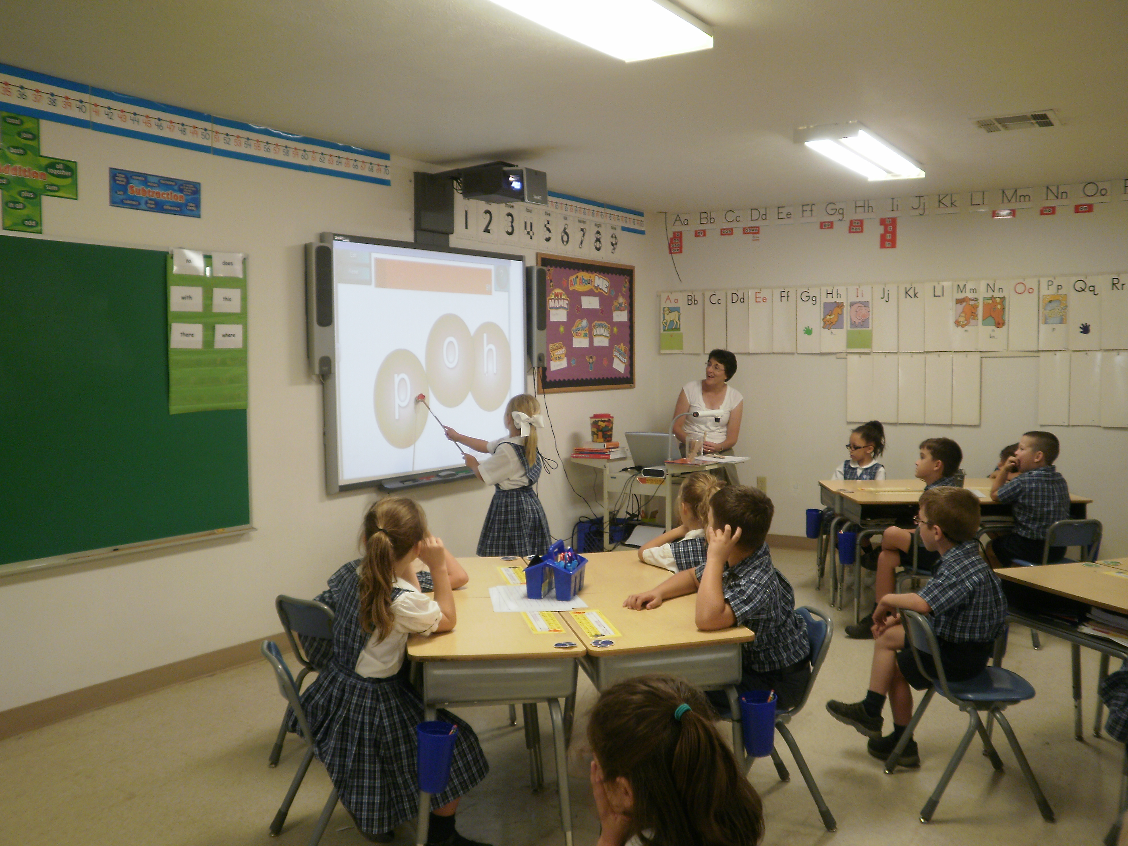

FIRST GRADE NEWS
SHS is very proud to welcome Mrs. Cindy Roblin 1A, and her assistant Ms. Mary Muchinjiko. The first graders in 1-A will be busy learning many new skills! They will be blending numerous words and participating in oral reading and journal writing. Addition and subtraction in math along with place value will be practiced to ensure mastery. Many social studies and science skills will be explored and discovered. The students in 1-A will continue learning about “God's good deeds” and practicing all that is learned.
Mrs. Kathryn Moreau’s first graders in 1B have gotten off to a wonderful start. They have started reading in decodable books, and love working math using new manipulatives. In English class, they are working hard on capital letter skills. The class is learning the “Rules of The Classroom” and Mrs. Kat feels they are following the rules beautifully. The class is excited about the Fall Fair in October and can't wait to work on the class project with 1B’s room mothers. Mrs. Josephine Chimwe is assisting, and Mrs. Kat appreciates having her in class. We hope the rest of the year goes by as fast as the first few weeks have!

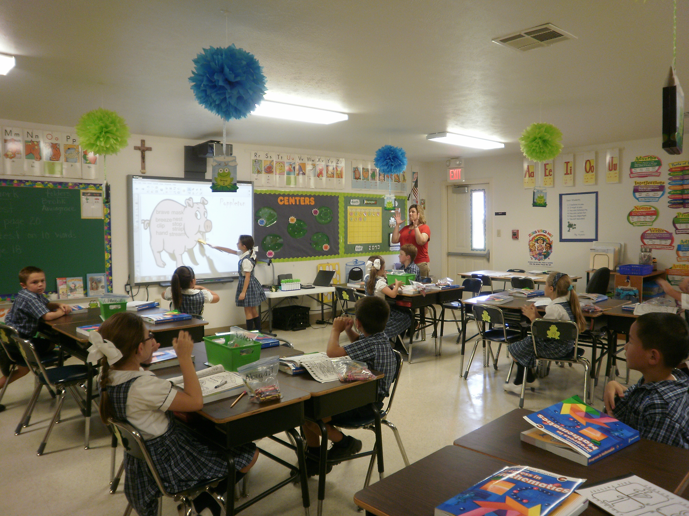
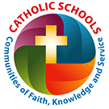
SHS TEACHER’S WISH LIST CORNER
1-B – (27) Subscriptions to Scholastic Magazine
2-B -ETA Cuisenaire Rulers for inches & cm #525
3-B – (28) Individual Student Whiteboards
4-A - An Electronic Globe
4-B & 5-B Test Tents
Library – 5 I-Pads

SECOND GRADE NEWS
Mrs. Michelle Daigrepont’s 2A class has jumped right into Common Core with many group activities and partner work. The students have adjusted well to Kagan Strategies and Whole Brain Instruction. In the short time school has been in session, the students have been busy learning about the author Cynthia Rylant. They have been determining the author's purpose, main idea, characters, setting, problems within the stories, and the solution to the problems. Mrs. Carmen has incorporated their reading unit "Seasons" into her art lessons. This has helped the students understand the unit from different perspectives. Mrs. Michelle is planning a trip to the Moreauville library to check out some of Cynthia Rylant's books. In English, the students are mastering adjectives, adverbs, contractions, and possessives. In math they revisited addition and subtraction facts, doubles, fact families, and many word problems. We are now discussing the sacrament of Baptism in Religion, and the water cycle in science. The students really enjoy "Center Time.” During center time they work on the I- Pads, read class library books, and take AR tests, work on math skills, and English skills.
In 2B Mrs. Darla Tassin’s students are getting off to a great start! So far they have worked on comparing stories using a Venn diagram. Also, they have learned how to work together in group activities, and started accumulating points in AR. They love playing 2B baseball each week and are intrigued about reading Charlotte’s Web. The best is yet to come!

THIRD GRADE NEWS
Students in Ms. Christel Voorhies’s 3A class plan to integrate critical thinking activities on the Smart Board in language arts. In math the students will work on activities for corrective learning in division with two-digit quotients with and without remainders. In social studies the children will learn about their country, state, and community through smart board activities. In science the third graders will learn about nature, space, and basic facts on the human body. Reading and writing activities are encouraged at home.
In 3B, Mrs. Betty Augustine’s third graders are excited about learning! The Common Core Curriculum has opened group discussions and numerous activities. Students are learning skills needed to function well in “the real world.” These skills include speaking softly in a group, respecting others’ opinions, sharing ideas, along with giving and receiving constructive criticism. Because of the numerous activities and lessons planned for the new school year, all parents are invited to visit and take an active part when possible.

SHS NEWSLETTER Grade Level News Page 3 of 4
FIFTH GRADE NEWS
Mr. Joel Tassin’s 5A class is departmentalized for the first time in a long time. The students have responded beautifully and have adjusted to the exchanging of classes, utilizing lockers and completing assignments for four different teachers. In math, many timed mental math exercises are being used to empower students to think and focus using common core standards. In science, students are utilizing the scientific method to complete scientific investigations for each unit. A bonus for fifth grade this year is that SHS is participating in the STARBASE Program offered at Camp Beauregard. Both sections are participating.
SHS welcomes Mrs. Tara Gauthier to the school family. Mrs. Tara is 5B homeroom teacher. 5A and 5B are attending STARBASE. It is a five day educational enrichment program. The classes are centered on science, technology, engineering, and math education. It is a very hands-on activity based experience, that will cover topics such as Newton's Laws of Motion, properties of air, computer technology, engineering, team building, basic chemistry, geometry, nanotechnology, model rocketry, and computer flight simulation. Certified educators will teach the program with assistance from volunteers with the military.
In Language Arts students are working on the novel Because of Winn Dixie. They are enjoying this literature based approach to common core skills. Students are working on character trait analysis, comparing and contrasting of the main character to ourselves, and they are working on building vocabulary. The new Spelling/Vocabulary program is challenging us to aim high. They will be starting their silent auction item for the fair very soon. They can't wait for everyone to see how it turns out.

SIXTH GRADE NEWS
Mrs. Maria Burke is looking forward to another very busy year in sixth grade. This year’s selection of The Red Fern will be read and the class will be focused on “who people are, the character of a person, along with who you are affects others.” Seventh grade literature this year will include the reading of House of the Scorpion. This will deal with modern social ethical issues. Eighth graders plan to work on essays, along with responding and analyzing in literature, and current events. This year the students will be reading, Lord of the Flies.

Mrs. Tammy Guillory in 4A reports that the
students are excited and are having fun learning and using new vocabulary words from the new series work books. Spelling is a challenge, and reading is all about Greek and Roman Mythology. Social Studies is a favorite as the students get to map out and learn details about the five regions of the United States. The students in 4-A and 4-B really like being departmentalized. The transition between 4-A and 4-B is going smoother than expected.

Ms. Carla Moreau’s students in 4B are quickly adjusting to many changes this school year. Ms. Carla teaches math, science, and religion. Mrs. Tammy teaches ELA and social studies. In math, the focus is on mastering multiplication facts. It is crucial that the multiplication facts are mastered. In science they are studying the properties of matter. They are also learning about the elements on the Periodic Table.
A MESSAGE
FROM
THE PASTOR

“We have successfully launched a new scholastic year here at Sacred Heart School, and with a lot of hard work and preparation our new school year 2013-14 is now in session. We read in the wisdom literature in the Sacred Scriptures: “Let the wise hear and advance in learning, and the one who understands gain sound guidance (Proverbs1:5)” Also, “an intelligent mind gains knowledge, and the ear of the wise seeks knowledge” (Proverbs 18:15). Our mission in Catholic education is to be instruments of God in the formation of the whole person. Let us pray together as we begin this new school year that God will help our teachers and staff, and our returning students to accomplish the mission God has entrusted to us with the help of his grace, and that we may glorify his name in all we do.” Fr. Marc Noel
ART NEWS
In conjunction with Sacred Heart’s common core curriculum, Mrs. Carmen Necaise’s Art class will tie in this year’s art projects with the primary subjects of ELA, science, social studies, and math. In addition, music will be incorporated into the lessons as a creative aid. Technology will also be integrated into the classroom to expand the lessons from traditional media to multimedia.

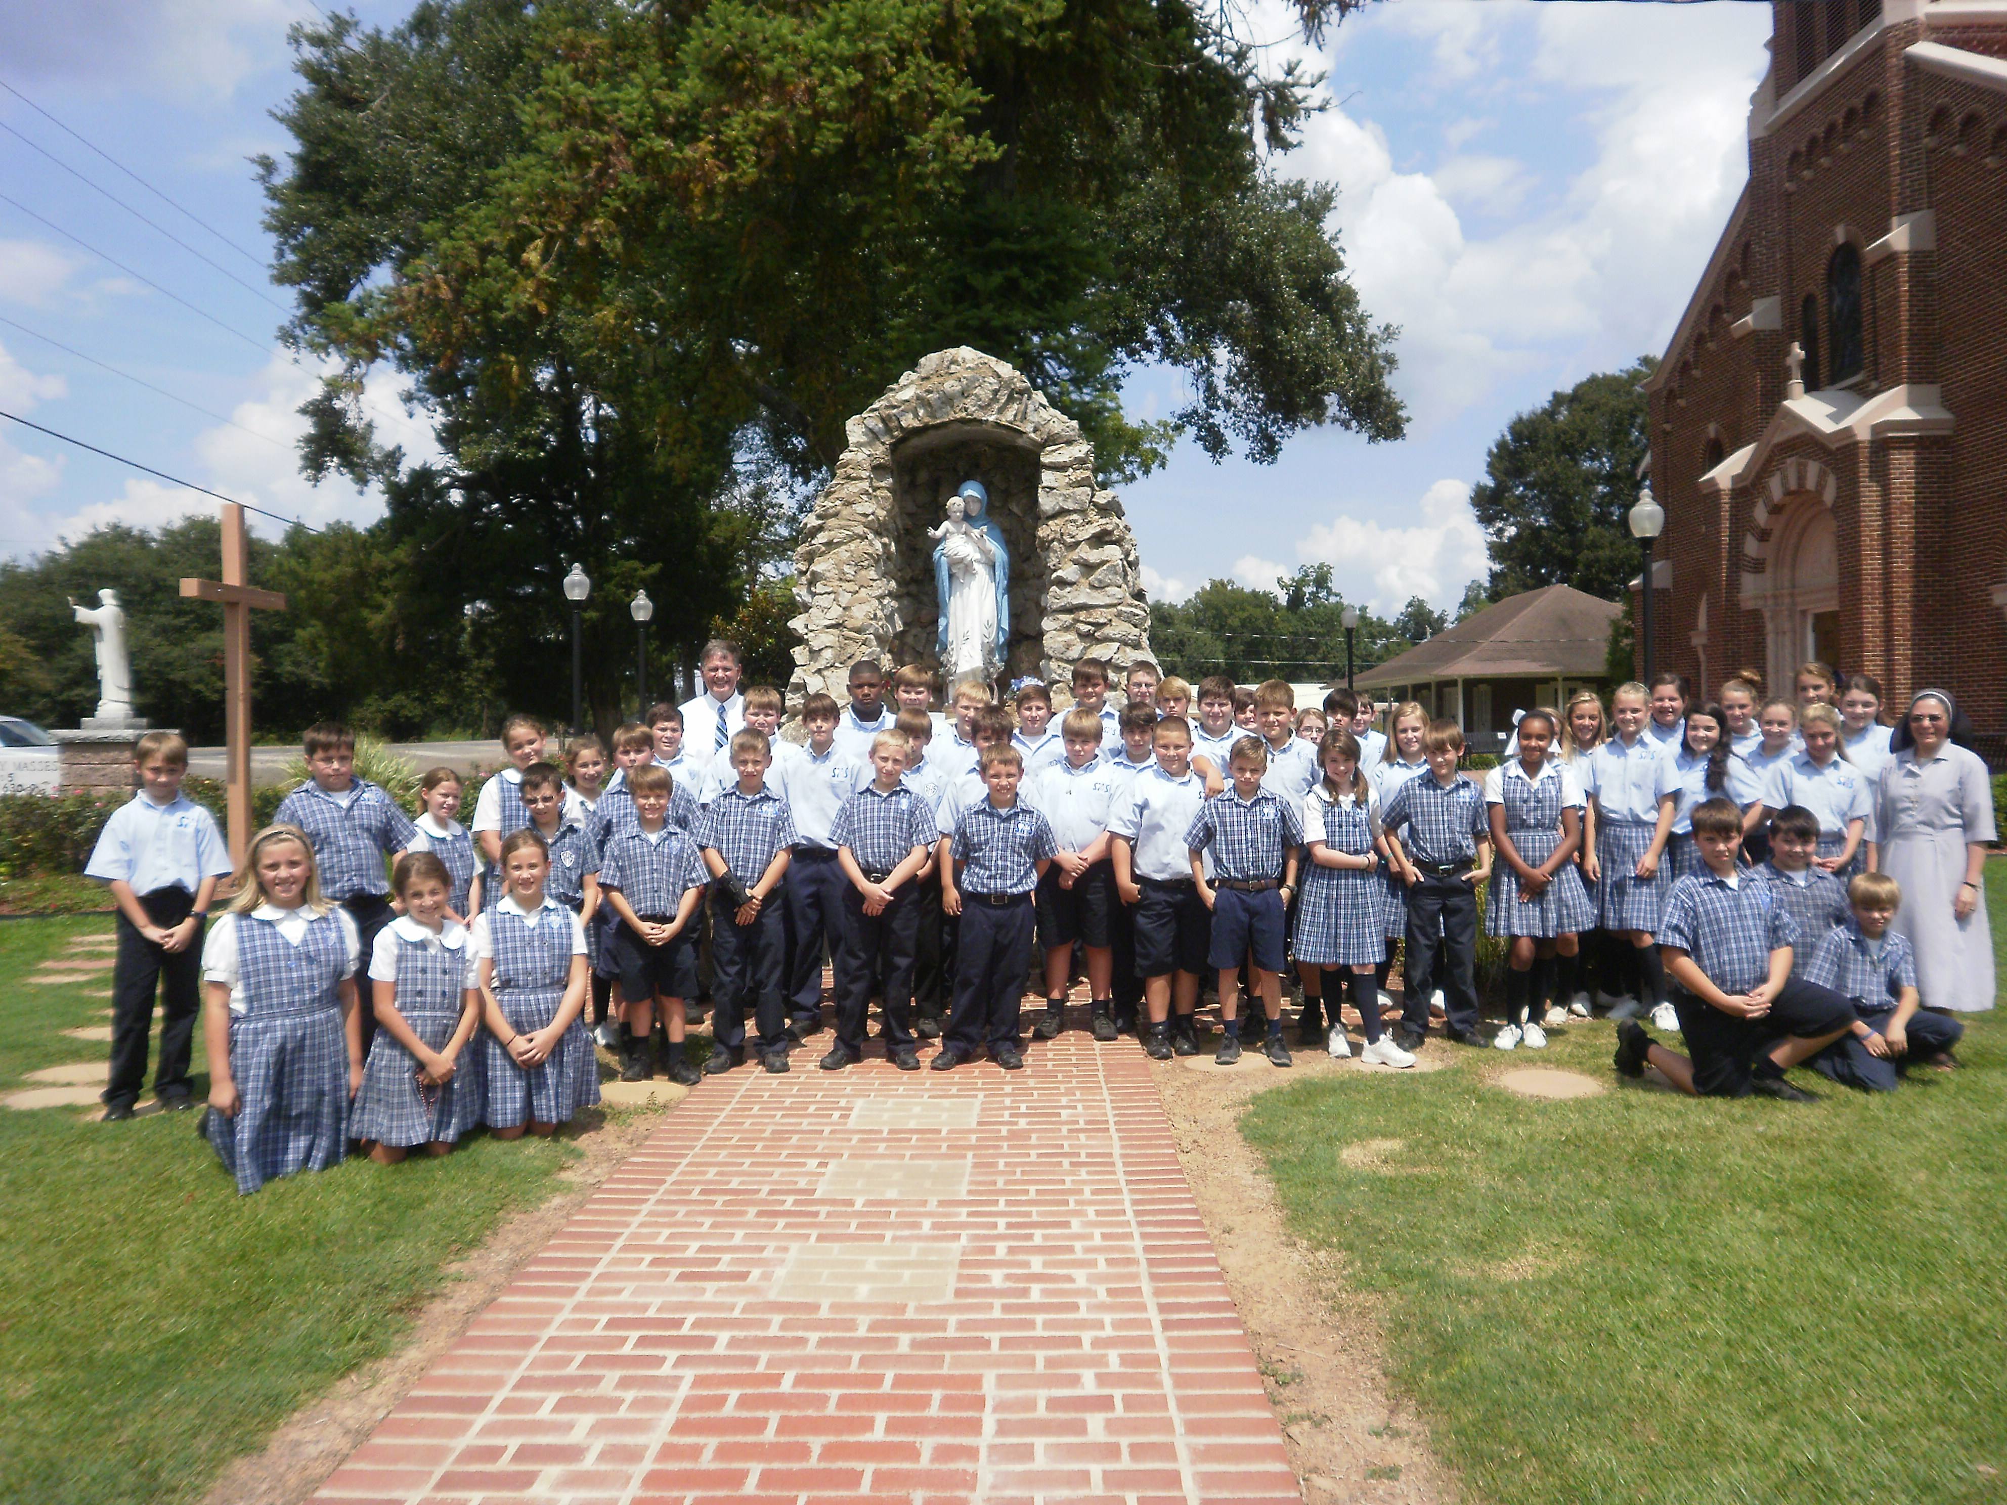
Nativity Rosary

FOURTH GRADE NEWS
FROM THE SHS LIBRARY
&
TECHNOLOGY LAB
Mrs. Rhonia Smith’s classes are hard at work reading and taking Accelerated Reader Quizzes. The sixth, seventh, and eighth grade Technology classes are busy learning to work on the iPads. They are also researching the key terms that they will be using throughout the school year. They have several projects that will be assigned to work on this year with Power Point, Keyboarding, and Publisher.

The SHS
Columbian Squires Club
The SHS Columbian Squires Club sponsored a Holy Rosary on September 6 to celebrate the Nativity of our Blessed Mother. The Squire Officers led the rosary and our youth girl’s choir sang to honor the Blessed Mother. Mr. Marvin Guillot, sponsor, would like to thank Sister Delnise, and Mrs. Karen Moreau for their help. Mr. Marvin is very proud that many fifth grade boys are joining the Squires.

NEWS FROM THE ASSISTANT PRINCIPAL
Mrs. Darcy Bordelon, assistant principal, welcomes back all SHS faculty, students, and staff. “It is hard to believe that our summer vacation is over and school is back in session. It was a joy to see everyone’s smiling face on the first day of school. I also enjoyed seeing everyone wearing their black/white shoes. It looked so nice. Parents thank you for your cooperation. We have many fun things planned for the school year, and I know your child will enjoy each and everyone of them. A few new procedures have been implemented. First, if a student is tardy, he/she must come to my office to check in and receive a pass allowing them into the classroom. When a student has a uniform infraction, a form will be sent home notifying the parent of the problem. For discipline problems, there is also a special form to be sent home. This is to help keep parents informed of what is happening. I look forward to working with each and every one of you. So please, if you have any questions do not hesitate to call.” Mrs. Darcy Bordelon

Religion Department
Sr. Delnise will be teaching religion in grades 3A, 5A & 5B, and eighth grade. Sister Delnise attended the rosary sponsored by the Columbian Squires on September 6 and shared these comments: “In the middle of the day, feeling the hot Louisiana weather just starting September, a group of brave students of Sacred Heart School gathered together in front of the Church to pray the Rosary. The enthusiasm to live our Catholic faith involves our students and invites them to be a witness of love for our Blessed Mother celebrating her Nativity. Praying with them as a religion teacher, I feel privileged being part of Catholic Education. I am grateful to see my third grade students learning about the roots of our faith. It is also delightful to see the eyes of our fifth graders discovering the beauty of God’s love for us in the Sacraments and our eighth graders learning about the Church and our Salvation History with heart of disciples. With Blessed Elisabetta Renzi, I want to say to each one of them and to the whole world, “Be happy because the Lord loves you!” Sr. Delnise Silva

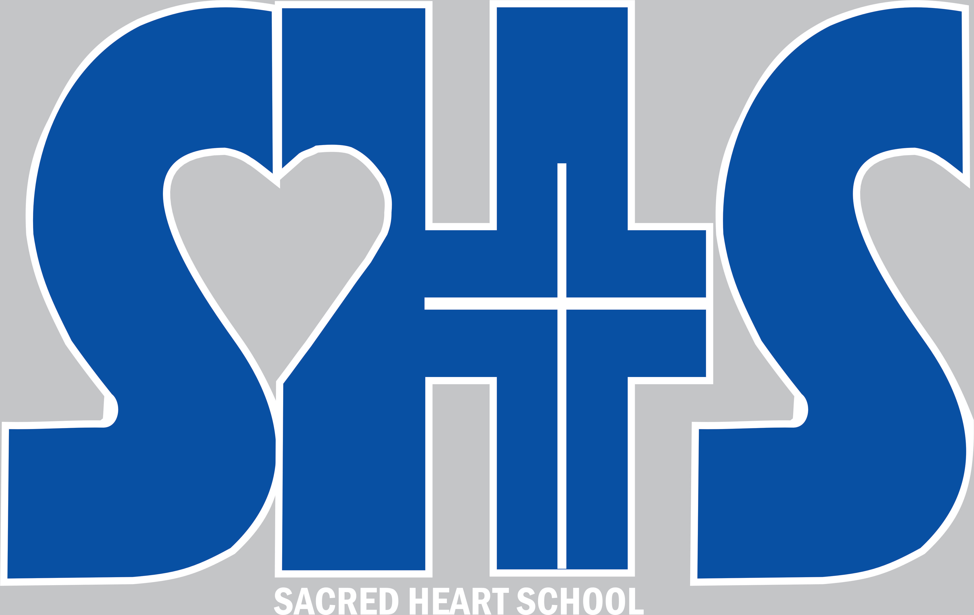
We’re on the Web!
www.shsmoreauville.com

Mr. Marvin Guillot is our seventh grade homeroom teacher and will teach social studies in grades five through eighth. Fifth grade is learning about the early trade routes and explorers while the seventh graders are learning about the Thirteen English Colonies. They are reading the story Johnny Tremain. The sixth graders are learning about Egypt and our eighth graders are studying Louisiana Government.

Mrs. Michelle Deshotels’s math classes in seventh grade are presently working on ratios and proportions, along with unit prices and real world applications. The eighth graders are working on solving equations,
1-step, 2 step, and now on multi-steps to solve variables, and then moving into inequality. Parents are encouraged all year to review and prepare their children for the Leap Test.

SHS welcomes Mrs. Marcy Center. Mrs. Marcy is the eighth grade homeroom teacher and will teach science in grades six-eighth. She will also teach religion in grades six and seventh. In addition, she is teaching vocabulary to seventh grade. This year Mrs. Marcy will also sponsor Jr. Beta. We want to thank Mrs. Rhonia Smith for all of years of service as Jr. Beta sponsor. Mrs. Marcy commented that, “SHS has been heaven on earth as jobs go!”
SACRED HEART SCHOOL 2013 FOOTBALL SCHEDULE Coaches: Mr. Marvin Guillot (Athletic Director) & Mr. Joel Tassin
September 3 – Jamboree – HOME September 10 – Prompt Succor – HOME- B GAME ONLY September 17 – St. Mary – HOME September 24 – St. Anthony – AWAY October 1 St. Anthony – HOME October 10 Prompt Succor – AWAY – B Game; Menard – Away – A Game October 15 St. Mary- AWAY

As we prepare for our Fall Fair Silent Auction on October 19, we are very proud to announce that an autographed LSU football and player’s card from Heisman Trophy Winner Billy Cannon will be one of the featured items.
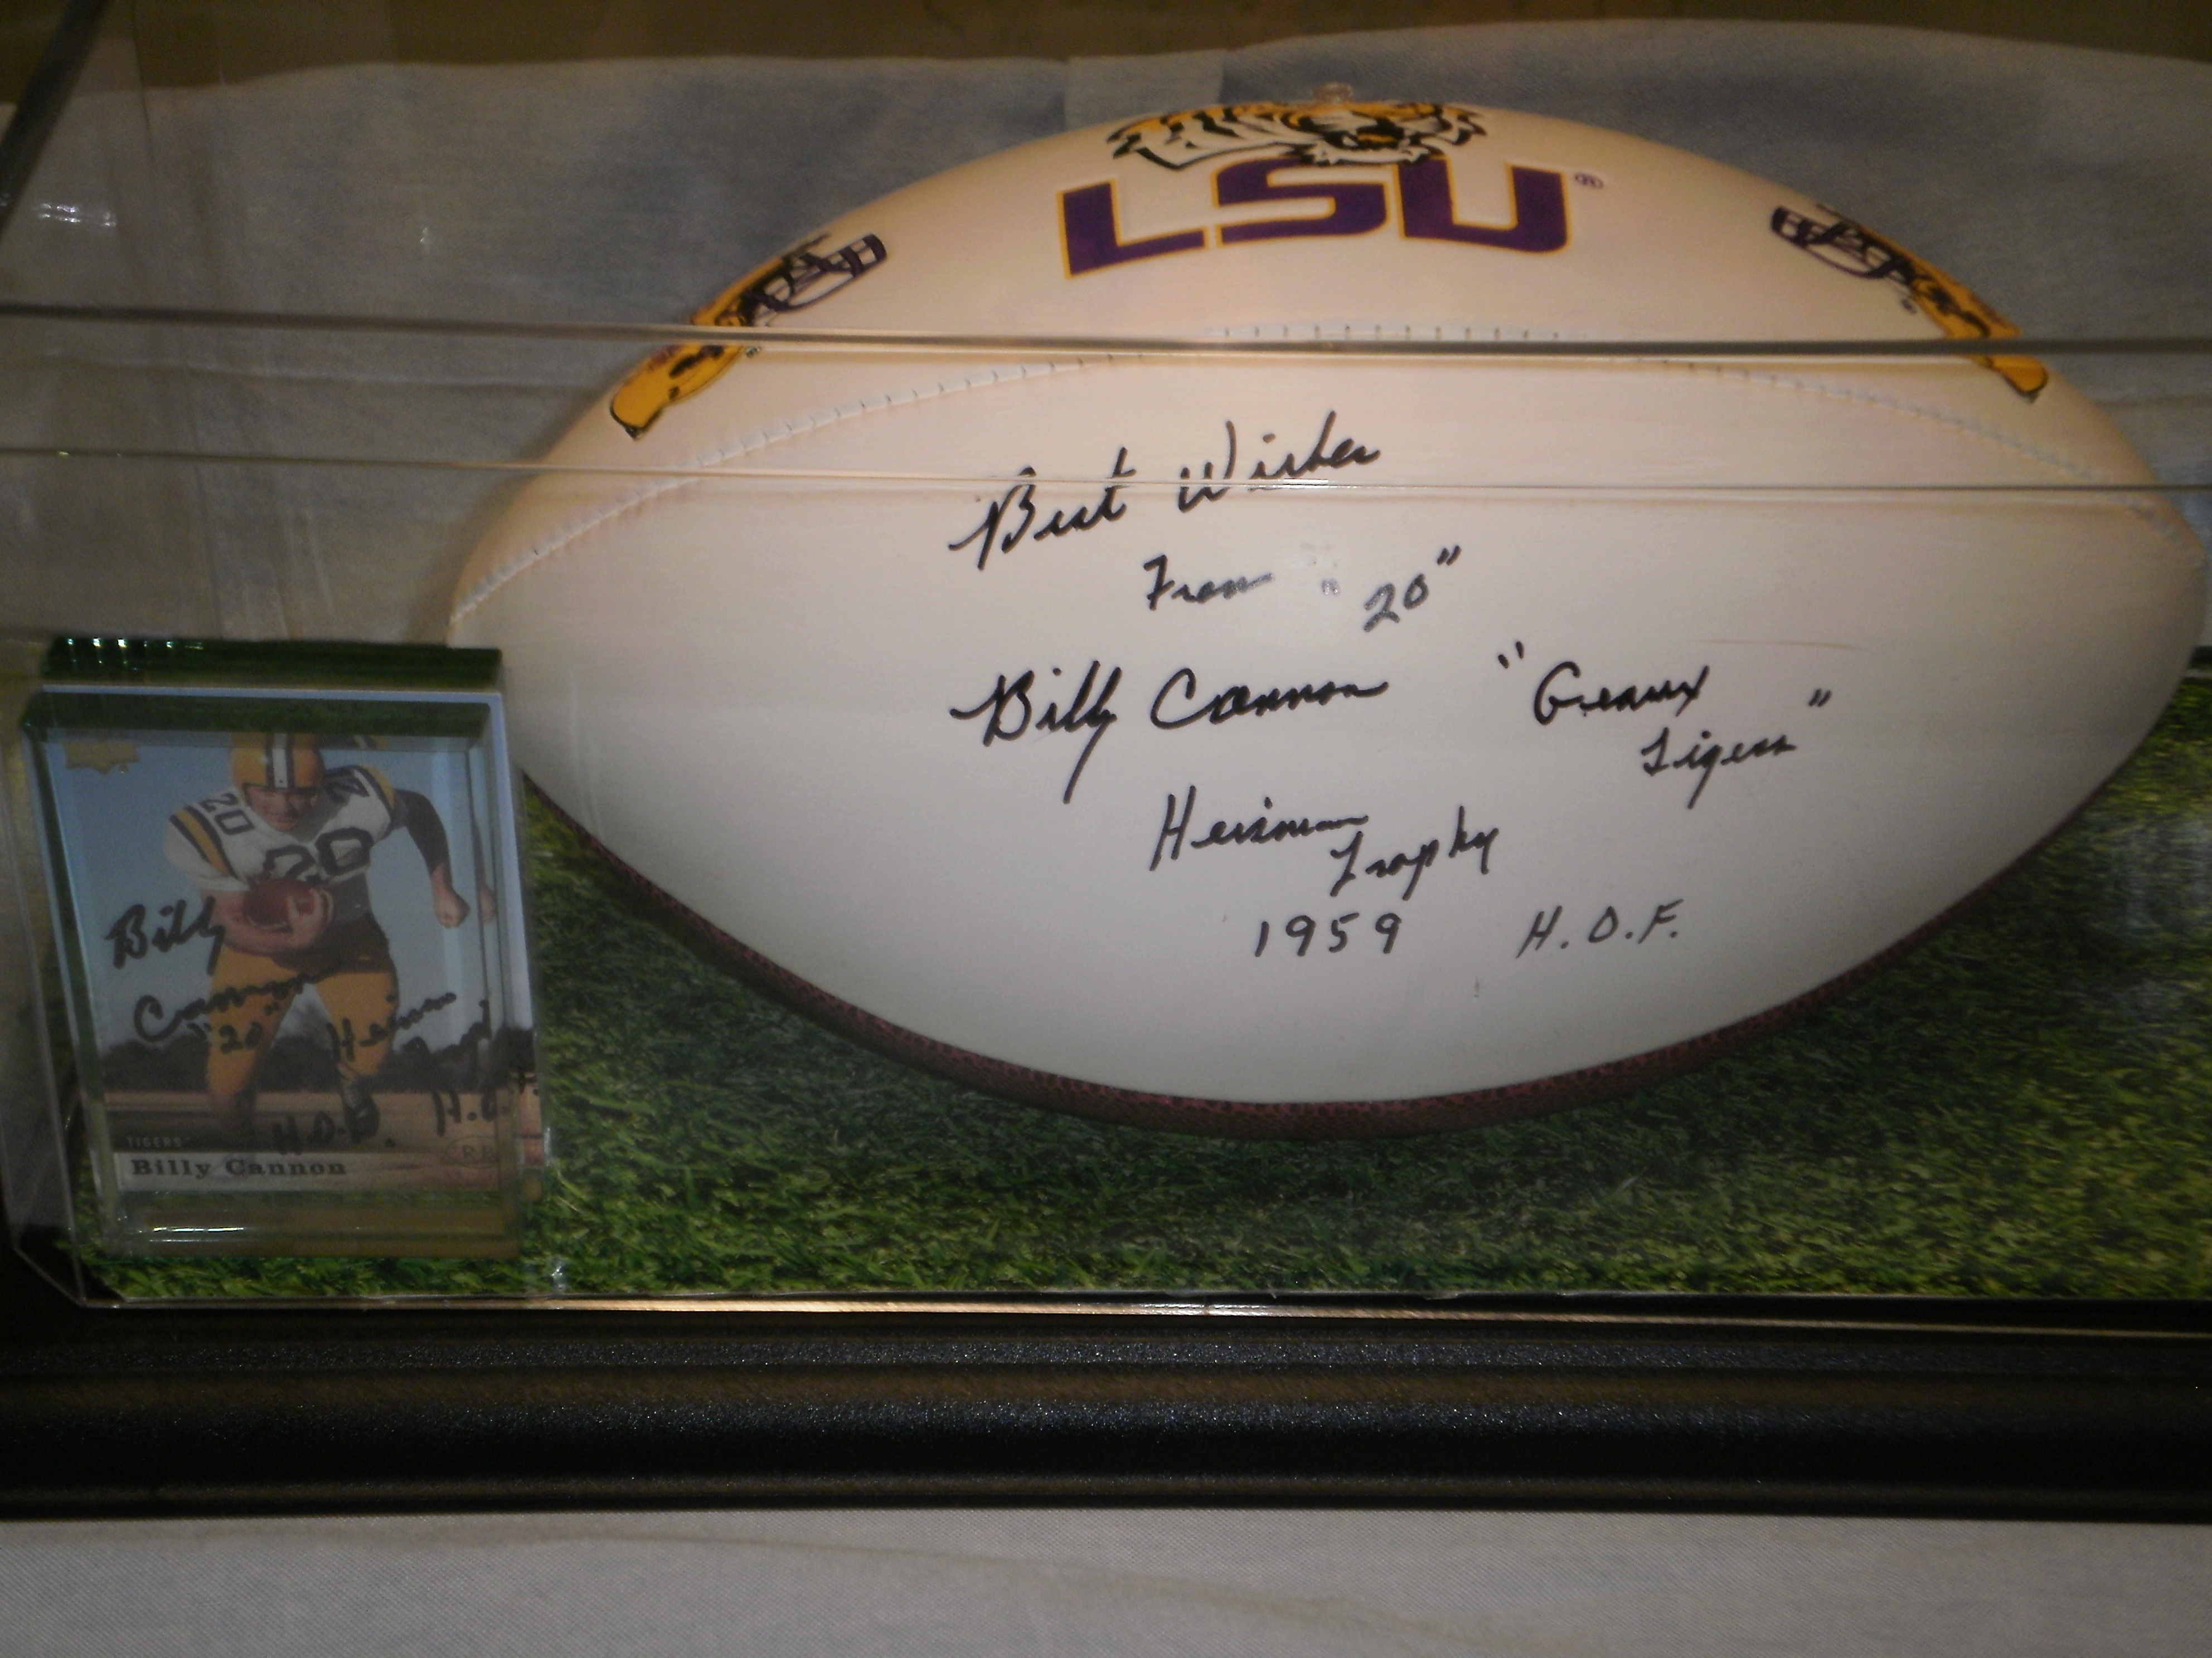

Seventh & Eighth Grade News
Sacred Heart School
9968 Bayou des Glaises
P.O. Box 179
Moreauville, LA 71355
Phone:
318 -985-2772
Fax:
318-985-2164
E-mail:
info@shsmoreauville.com

“SHS Celebrating 114 years of Academic Excellence”

Sacred Heart School
9968 Bayou des Glaises Rd
P.O. Box 179
Moreauville, LA 71355

SHS is proud to announce the new Athletic Director: Mr. Marvin Guillot. The SHS Football Jamboree was held on September 3. It was very successful. This season promises to be an exciting one! We would like to thank Coach Joel Tassin for working with Mr. Marvin in football. And thank you to all of our parent volunteer basketball coaches. Also Mrs. Angie Roy and her parent volunteers for sponsoring the Pep Squad and Cheerleaders.

