February 2016
Volume 5, Issue 2
Sacred Heart School Newsletter

PRINCIPAL’S CORNER
“The meaning of grateful is what I feel overwhelmingly in my heart for all the Sacred Heart School family! As we enter into this holy season of Lent, I want to assure all of you that each and every one of you are in my prayers, praying that you receive all the graces that you need to grow closer to the One who loves you without condition and immeasurably! The Church asks us to walk to Lent journey carrying only three things: prayer, fasting, and almsgiving. Prayer is greater and more frequent communication with God. Thanking Him for the many blessings that are freely given to us. Adoring God as the One who is all and that loves us more than we can ever imagine. Petitioning God for the graces we need, personally and/or for others. Confessing our faults and weakness asking God for mercy and forgiveness as well as the grace to be merciful as God is. Fasting is simply looking at our lives and consider what we can do without in order to grow closer to God. Perhaps to find some time in our busy lives to spend more quality time with our families. Consider to give what we normally spend on extra “likes” that we have and give to those who live without all the time. Can we give up some social media and maybe read a book that brings us closer to God, or use the technology that we use for social media and connect to the many apps that lead us to prayer or reflection? Almsgiving is sacrificing something in order to help others. There are many ways we can fulfill this challenge. It simply takes creativity. You have been so good at this already, giving of your time and your generosity to help support the school in all aspects, so I know you will take the Church’s challenge seriously. I look forward to walking this Lenten journey with you and your children. Thank you again for a wonderful first half of the year. We are already approaching pre-registration, please look for your packets and get them in as soon as possible. Open registration begins in March, at that time we will begin calling students who are on our waiting lists, so please make sure you secure your spot. Have a wonderful Lenten season and a beautiful rest of the year! I entrust all of you to the most Sacred Heart of Jesus.”Sr. Sandra Norsworthy

Contents
Principal’s Corner, PRE K, P.E. & Art News 1
Kindergarten, First, Second, Third & Fourth Grade News 2
Religion: First, Third, Fourth Grade 2
A Message From the Pastor, ELA, Science, Social Studies, Religion, Math, Technology, 5A & 5B News 3
News From The Assistant Principal, Athletics, 8th Grade Religion, Club News And Development & Alumni News 4

Fr. Jose Pallipurath, Pastor - Sr. Sandra Norsworthy, Principal
Mrs. Darcy Bordelon, Assistant Principal
Mrs. Karen Moreau, Director of Development and Stewardship

PRE-KINDERGARTEN NEWS
Pre-K A Sr. Kalen Sarmiento’s Pre-K A class is really working hard on different skills; including writing their first and last name, coin recognition, adding numbers and fractions. The students were given two topics for their Catholic School Week science project: “The Life of Butterfly Cycle” and “The Frog Cycle”. The students were excited and the joy they had on their faces was very rewarding. Sr. Kalen and Ms. Alyssa Smith would like to thank the parents for helping and spending quality time in making the science projects. The students are looking forward to the annual “Zoo Field Trip” and “Chuck E Cheese” on March 8, 2016. Sr. Kalen would like to take this opportunity to thank PRE-K A’s room mother Mrs. Tressie Bordelon for organizing the various activities during the year and all of the parents who always give their time supporting the class in various ways.
Pre-K B Pre-K B is fast on track preparing for Kindergarten. Ms. Angie Normand and Mrs. Jane Bertholl can tell how well their students are doing in school! The students enjoyed the Mardi Gras parade, and enjoyed making baskets to carry their beads in. They all felt like they were in a “big parade”. Some of the students are beginning to read classmate names and recognize words that are shown to them. The class will be starting to work more on STEM activities, and Ms. Angie promises that the students will love it. She also compliments her students on being great engineers and architects. The students enjoy coming to school!
P.E. NEWS
Mrs. Angela Schlumbrecht and Mrs. Raquel Lemoine are excited that the SHS PE students will be participating in Jump Rope for Heart again this year. They will also begin practicing soccer and softball/baseball. Archery is also in the curriculum this semester.
ART NEWS
The second half of the 2015-2016 school year, Mrs. Carmen Necaise’s Art Appreciation class will continue to work with non-traditional media in order to create specific works of art. Many of the classes will work on three dimensional art rather than two dimensional art.
SCHOOL OFFICE NEWS
Mrs. Brenda Coco, school secretary, has been busy getting registration packets together for students presently enrolled at SHS. She encourages each family to return these materials so that we can open registration to the public. Thank you Mrs. Sadie Thevis for all you do for us in our Finance Office! Ms. Britney Hopkins continues to work hard for all of us too! Thank you ladies for your continued ministry!

UPCOMING EVENTS:

February 15
Pre-Registration
February 29-March 4
School Mall Fundraiser
March 18
St. Joseph Altar
& Grandparents Day
March 23
Easter Triduum Tribute
& Living Stations

March 24- April 1 Easter/Spring Break
April 2
SHS Archery Tournament
April 21
Sacred Heart’s Got Talent Show
May 6
May Crowning
&
Field Day

May 12
8th Grade Graduation
May 20
Last Day of School

KINDERGARTEN NEWS
Kindergarten A has been working very hard in deepening their knowledge about Jesus. The students have learned to make better choices and “do what Jesus would do.” The atmosphere in the classroom revolves around Jesus every minute of the day. Academically, the students are getting ready for first grade. Catholic School week was filled with making cards for the teachers, parents, staff, and the elderly at Valley View Nursing Facility. The students in KA have a warm and generous heart for others and this is pleasing to any teacher. The students enjoyed the Mardi Gras parade and the 100th day of school. On March 22, KA and KB classes will take a field trip to the Alexandria Zoological Park and Chuck E Cheese. The students absolutely love the new playground equipment! Thank you on behalf of KA, Mrs. Karen Guillot and Mrs. Kim Dalgo!
Kindergarten B has been very busy too. Ms. Barbara Lang reported on the 100th Day of School the students enjoyed an ice cream party. The science fair topic on “The Weather” was a great learning experience. The students made miter hats for Catholic School Week and crowns for the Mardi Gras Parade with the help of Mrs. Denise Bordelon. On April 29 the students will celebrate Arbor Day by planting a fruit nearing pecan tree in memory of Sr. Martina Bernabe’ OLS. Besides all these FUN activities, the students do not forget to work on reading and math activities and remember how much Jesus loves them.

FOURTH GRADE NEWS
Mrs. Tammy Guillory’s 4A students came back from Christmas break ready to get back into the swing of things. The ELA classes have been having fun using adjectives in their reading and writing lessons. The classes have also enjoyed starting a new chapter book, “Because of Winn-Dixie”, which teaches about friendship and forgiveness. Social Studies has been enticing as the students discuss important time periods and events from the 1800’s -1900’s. The fourth grade is having fun with learning!

4B. Ms. Carla Moreau’s math and science students have settled back into their routine following a nice Christmas break. They have just completed a three week lesson on measurement and are now multiplying fractions. The students also participated in their first science fair where each student displayed 3D models of the four layers of the Earth. They were very excited! Students in 4B are still collecting money daily for St. Jude’s Children’s Hospital and will continue until the end of April when they will turn in their donation.

CATHOLIC SCHOOL WEEK -3A

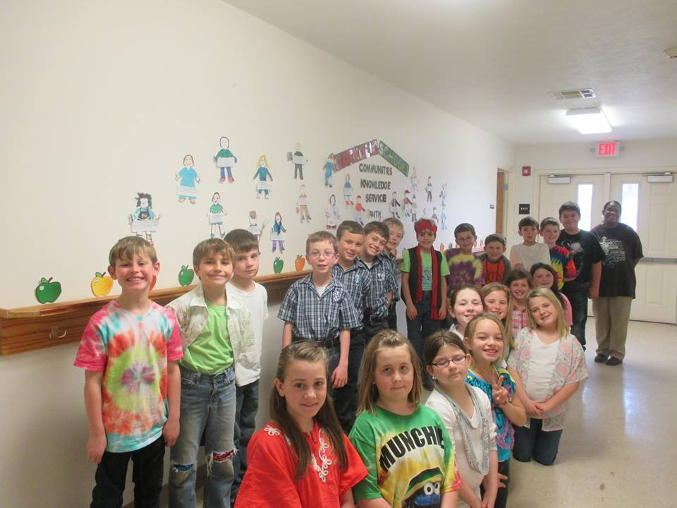
SHS NEWSLETTER Grade Level News Page 2 of 4
THIRD GRADE NEWS
Ms. Christel Voorhies’s 3A students are learning in Math, the relationship between division and multiplication. It is so important that the students master their multiplication facts! The students are enjoying writing poems and descriptive paragraphs. The Human body is being studied in Science, and the students are learning the functions and how to stay healthy. The students are finding it very interesting learning about the geography, unique history and the people of Louisiana.

The 3B class recently celebrated the 100th day of the 2015-16 school year and what an adventure it has been! Mrs. Betty Augustine and her 23 students have been working diligently on mastering all the skills of third grade. The students finished the first half of the school year with a bang. In Reading they have become very familiar with the new “Wonder” Reading/Writing series. The students have adjusted beautifully to the curriculum. In Math a majority of the students have mastered their multiplication facts and are currently focusing on long division. Now the students are working on decimals and percent as well as the concepts of geometry and algebra. The “Be a Scientist “notebook and computer program has truly inspired some of the students to start learning about careers in Science. The “Louisiana Experience” series had provided the class with a fun way to learn all about our state during Social Studies class. Every day is a new experience in 3B as the students venture towards fourth grade!

FIRST GRADE NEWS
Mrs. Cindy Roblin’s 1-A class was very excited to receive their first hard back readers. They have been working hard to develop stronger decoding and comprehension skills. Math skills have included Calendar Math which has helped them learn place value. The next adventure in math will be adding and subtracting larger numbers.1A enjoyed participating in the Science Fair during Catholic School Week and displaying their animal habitat projects. They have pledged to work hard for the remainder of this school year and are looking forward to becoming second graders.

Mrs. Claudia Crabtree’s 1-B class has found that the school year is passing very rapidly. The students were thrilled to receive their first hardback readers. Mrs. Claudia ask that parents, “Please spend time each evening listening to your child read and ask questions throughout the story to develop comprehension skills?” She continues, “Let’s keep learning as our main focus. I feel blessed to be able to teach a great group of our students.”

SECOND GRADE NEWS
Mrs. Michelle Daigrepont in 2A had a great time during the Christmas season preparing for the celebration of Jesus’ birth by performing in the SHS Christmas play. Now that the break is over the students are back and ready to work. In reading, the students have been learning about poetry, expository text, fables, information text, and are now working on folktales and drama. Math has been challenging with learning how to tell time and elapsed time. The students also worked on regrouping in addition and subtraction. Now, they are facing the challenge of counting money, making change, and comparing money. In Social Studies the students have learned a new game called, “Buzz the State” enabling them to learn all of the states and capitals. Now they are also learning about the solar system. Soon the class will be preparing for First Reconciliation and First Communion.

In 2B, Mrs. Darla Tassin’s students are publishing a class book. When the book is finished the parents will have a chance to purchase the book. It plans to be a best seller! Reading Day is coming up and the students need to start picking out their favorite characters. Math baseball is in full swing. The boys are ahead of the girls presently, but the girls are gaining momentum. The larvae for the spring lesson on the butterfly cycle will be ordered soon! The students love to release the butterflies outside on the playground.
RELIGION
First, Third, & Fourth Grade
Sr. Porimolla is very proud to report that: “The 3rd and 4th grade have broadened their understanding to the larger world, especially focusing on the church as universal and apostolic. They have learned, “We are many parts but one body in Christ”. We are called to continue His work by giving, sharing and using our faith, talents, and time with the Church community, and with the universal Church. The Seven Sacraments help and strengthen us to carry on our responsibility as members of the church. Jesus invites us to serve Him in a very special way by dedicating our life for him and follow his footsteps. The 1st, grade has explored the feasts and seasons of the Catholic Church. It was so much fun to read, to learn and watch the videos about the saints. Their lives of the Saints, and by their examples, they have inspired us to live a holy life and follow Jesus every day. The students have learned how to honor the saints who are now in heaven and help us and pray for us in our needs. They have also learned and experienced that the liturgical seasons are related to our faith journey. It helps us to change our life in a good way and to focus and participate with the life and ministry of our Lord. We have been enjoying our religion class and are expecting to have a grace filled rest of the school year.”

SHS NEWSLETTER Grade Level News Page 3 of 4
ELA, SIXTH GRADE B, SEVENTH
& EIGHTH GRADE
Mrs. Jessica Nimtz’s ELA classes: 6B is enjoying “The Secret Garden” by Francis Hodgsen Burnett. The students have been incorporating more technology into their reading discussions with a program on the new Smart Board called “Shout it Out.” The students can post their response to the Smart Board using an iPad or laptop. The students have found this to be a more thorough and engaging way to have discussions. For writing, the students are currently working on a research paper over a topic of their choice in relation to “The Secret Garden”. A visual presentation will follow.7th grade has just started “Across Five Aprils” by Irene Hunt and are enjoying using their new Chrome books in the classroom. They can answer discussion questions by posting to Google Classroom and they can also post to the Smart Board using their Chrome Books with a program called “Shout it Out.” For writing, students are working on a persuasive essay over a topic that the class chose, and later the class will have a debate on this topic. 8th grade is enjoying “Treasure Island” by Robert Louis Stevenson and are using their new Chrome books in the classroom for their reading discussions. They can respond to posts in Google Classroom and also post to the Smart Board using a program called “Shout it Out.” For writing, students are working on a persuasive essay over a topic of their choice and later they will be presenting a persuasive speech along with a visual presentation.
6A & MATH 5-8
Sixth grade students are learning and applying the rules for adding, subtracting, multiplying, and dividing integers: solving equations with integers by applying the Properties of Equality for Addition, Subtraction, Multiplication, and Division; evaluating equations using substitution. Mr. Joel Tassin
6B, MATH & ALGEBRA
This semester the 6th graders will be learning the following in Math: A. Fractions: Multiplication, Division, and Probability; B. Data and Statistics; C. Geometry; D. Ratio, Proportion and Percentages; E. Measurement. The 7th graders will be learning the following in Math: A. Operations with Fractions including Algebra with Fractions; B. Ratio and Proportions; C. Percentages; D. Data Analysis and Statistics; E. Two-Dimensional Geometry;
F. Probability; G. Patterns, Relations, and Functions; H. Polynomials and Equations.
The 8th graders in Algebra 1 will be learning the following in Math: A. Operations with Polynomials; B. Factoring Polynomials; E. Radical Expressions and Equations; F. Quadratic Functions and Equations; G. Ratio, Proportion, and Trigonometry; H. Rational Expressions and Equations; and an intense review of topics in Math to prepare for the EOC testing.
Mr. Dan Soldani

A Message from the Pastor

“One of the basic things people want in life is happiness. Many people live happily and some live unhappily in this world. People are constantly in search of happiness. It’s hard to find happiness, but it’s possible. There is nothing better than being happy in life.”The secret of being HAPPY is accepting where you are in life and making the most out of it.”

The ultimate goal of education should be to enable a person to lead a happy life. “Educating the mind without education the heart is no education” says Aristotle. Therefore education should focus on educating the heart too. Ethical and religious values and humanitarian principles need to be inculcated in the young hearts as they are helped to form themselves in social beings. May our efforts as parents, teachers, and caretakers be rewarding! May we and our young ones be happy always! May God Bless you!” Fr. Jose Pallipurath

SCIENCE
Ms. Sherill Austin's 5th grade class is studying Life Science. The students will proceed to study Earth Science. The 6th graders are now studying atoms. Electricity, electromagnetism, sound, and light will be the next topics to discover. The 7th graders are studying about animals and then will study about the human body system. In the spring, they will learn about plants. In between some of our lessons from the text book, they will be reviewing experimenting questions and graphs as this is a big part of science. The 8th graders will be studying several chapters from unit 4, “Reshaping the Land”. They will also be studying some of the chapters about Oceanography, Weather, and Climate, along with Astronomy. In between some of our lessons from the text book, we will be reviewing experimenting questions and graphs as well.
RELIGION & 5A
Religion in 5th, 6th, and 7th grade has been packed with rich Catholic culture and tradition this semester! 5th Grade: The students are becoming better acquainted with the marks of The Church: One, Holy, and Apostolic and what this means to be followers of the Mass. They are discovering the Magisterium, or The Church as a teaching Church! 6th grade: Students are learning the Gospels asThe Good News! Mrs. Amanda wants her students to know how much Jesus understands them and their lives. primarily because he was once their age and was fully human and without sin as the Son of God. This concept has taken them into in deep discussions.
7th grade: The students are discovering that sin is real as Original Sin and Personal Sin. However they are simultaneously coming to know that Personal Holiness is equally as real and we are called to as Catholic Christians to follow our Mother Church. “I love as their teacher, being able to stress God’s Mercy at such a perfect time as our Holy Father called for this Year of Mercy! We pray the Angelus as a class everyday at the 12:00 noon bell. Thank you all for continuing to allow me to assist you in forming the future leaders of our beloved church, your precious children.” Mrs. Amanda Lacombe

SOCIAL STUDIES
FIFTH-EIGHTH GRADE
Ms. Ethel Baudin‘s 5th grade class has studied numerous facts about several of the continents and are now studying facts about North America. Within these facts they are discovering the people who first came to this country and how it was created. In 6th grade, the students, after discovering Mesoamerica, will now travel back to Europe to discover the development and decline of several empires and how it affects our world today. In 7th grade, the students are learning about how our nation took shape through successes and struggles. The 8th graders are continuing the learning journey of the various governorships that have made Louisiana the state we live in. They will soon study where our settlers will become part of a greater colony which is now the United States.
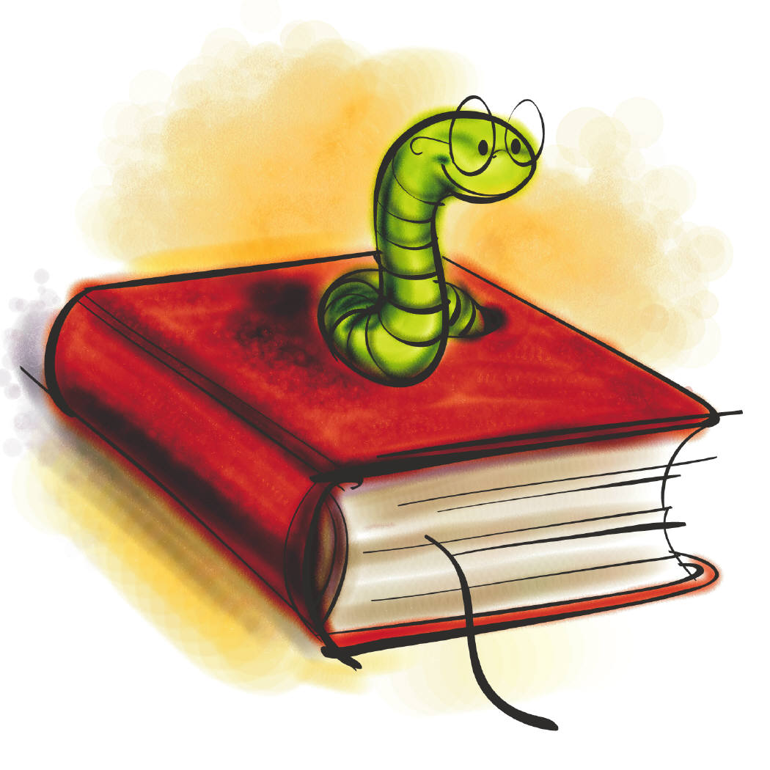FROM THE SR. MARISA RICCI MEDIA CENTER Mrs. Rhonia Smith is proud to report that all of the classes have been working hard on their Accelerated Reader Quizzes. Many of the students use the Media Center at recess to study and work on other projects. In Technology, students are working on many different projects. The 5th graders are beginning to learn all of the “Key Terms” dealing with computers. The 6th graders are making “Front Page Newspapers” with articles. The 7th and 8th graders are learning about Social Media Safety and will be creating a video on: “How to keep your accounts safe.”
FIFTH GRADE B
Mrs. Amy Lemoine is anxious about the new exciting semester! The 5th graders have really adapted to the new reading program, “Wonders”. It is giving them a new perspective on different ideas and teaching them many useful new terms. The stories are interesting and fun to read! The 6th graders are reading “People of Sparks” which is a sequel to the “City of Ember”. They are really enjoying the book and are curious to find out what happens to all of the characters. Parents: be looking for a project after the students complete the book.

THANK YOU MR.ALFRED AND MRS.BARBARA FOR YOUR
CONTINUED HARD WORK
IN MAINTAINING OUR CAMPUS!

Sacred Heart School
9968 Bayou des Glaises Rd
P.O. Box 179
Moreauville, LA 71355

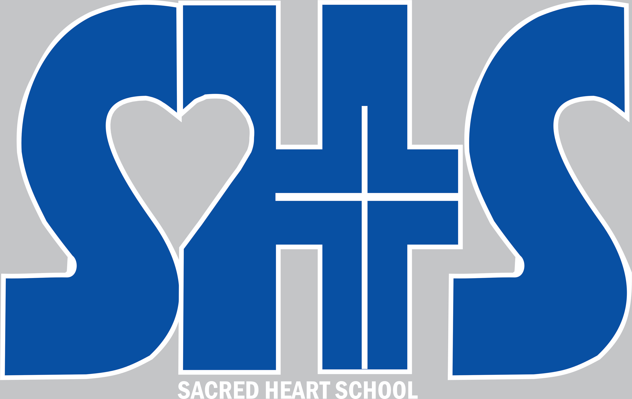
Sacred Heart School
9968 Bayou des Glaises
P.O. Box 179
Moreauville, LA 71355
Phone:
318 -985-2772
Fax:
318-985-2164
www.shsmoreauville.com

RELIGION
EIGHTH GRADE
Sr. Sandra Norsworthy has been working with the 8th graders on leading “The Stations of the Cross” on Fridays after Mass. They are also preparing for: “The Easter Triduum” and “The Living Stations of the Cross” to be held on March 23.

NEWS FROM
THE ASSISTANT PRINCIPAL
“Dear Grandparents, Family, and Friends,
Because of your generosity and support we were able to purchase our new playground equipment. Watching our children play on this new equipment fills my heart with such joy! I’ve had some to tell me we got it right and some to tell me they feel young again! (Oh, if they only knew what old feels like!) As all of you know we had parents and KC’s who helped to install the new equipment—for this we are eternally grateful. Our benefit dinner was a great success! Thanks once again to all for your support and help. The proceeds were used for the playground groundcover. Our Book Fair was also a success and once again thank you from the bottom of my heart for all that you do for the school. It is greatly appreciated. WE are truly blessed to have you all at SHS. Please stop by to see the new playground. You too may find that “Fountain of Youth” again. God bless each and every one of you!” Mrs. Darcy Bordelon
ATHLETIC NEWS
Congratulations to all of our athletes on a successful basketball, and football season! Archery is still progressing nicely and there will be an Archery Tournament at SHS on April 2.Baseball and softball season will begin on February 27 with the Catholic League Jamboree. Good luck to all of our coaches and players. Go Lions!

DEVELOPMENT
& ALUMNI NEWS:

PLEASE JOIN US FOR HOLY MASS, BLESSING OF THE
ST. JOSEPH ALTAR AND GRANDPARENTS DAY
TO BE HELD ON
MARCH 18 IN THE SHS GYMNASIUM!
8:30 AM

THANK YOU FOR ALL YOUR SUPPORT IN OUR NUMEROUS FUNDRAISING EVENTS!

CLUB NEWS
The Congregation of the Children of Mary and The Columbian Squires held their induction ceremonies on February 5, after this year’s Catholic School Week Mass. These two service organizations are vital to SHS’s student ministry in grades 5-8. The groups assisted with providing and selling cakes for the Playground Benefit Dinner Bake Sale and some of the members help spread ground cover for the playground. Jr. Beta is planning a Spring Fling! Details will become available later. Clover Buds and 4-H members have been working hard on various activities and we are so proud of all of their accomplishments! In December our club collected and assembled 21 shirt boxes of coloring books, crayons, stickers, and activity book. They were delivered to the Lady of the Lake children s hospital as part of our Community service project. Thank you students for all that you do for our school!

STUDENTS OF THE YEAR 2016


