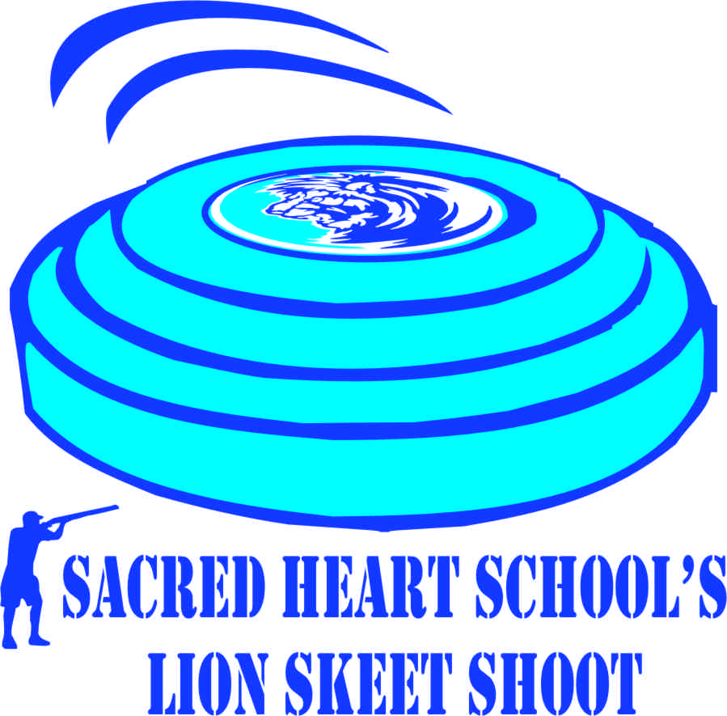
April 25, 2015
Federal ID# 72-0989059
TRI-PARISH SPORT CLAYS, HOUMA LA
REGISTRATION FORM
Sponsor Name:
Address:
City/State/Zip:
Email:
Telephone Number:
PREFERRED MAIN EVEN SHOOTING TIME (CIRCLE ONE) 8:00 a.m. 11:00 a.m. 2:00 p.m.
**In the event that there are not enough teams to fill three flight, flight times may be adjusted.
Your team will be contacted in the event that this occurs.
___________________________________________________________________________________________
TEAM CAPTAIN T-shirt M/L/XL/2XL/3XL City/State/ Zip Phone/Email
____________________________________________________________________________________________
TEAM MEMBER #2 T-shirt M/L/XL/2XL/3XL City/State/ Zip Phone/Email

TEAM MEMBER #3 T-shirt M/L/XL/2XL/3XL City/State/ Zip Phone/Email

TEAM MEMBER #4 T-shirt M/L/XL/2XL/3XL City/State/ Zip Phone/Email
_____________________________________________________________________________________________
ALL PROCEEDS BENEFIT SACRED HEART SCHOOL

SACRED HEART SCHOOL’S LION SKEET SHOOT
TEAM PACKAGE

Four Man Team Lion Pride Pkg.: Includes - Main Event (100 shots each Team Member), 5 Stand (25 Shots each Team Member). Long Bird (4 Tickets 10 shots each Team Member), 2 Man Frenzy ( 2 Score Cards per Man Team), and per flight on course Team Poker Run.
Package Total: $1200.00 Qty.__________

Additional events may be purchased as follows:
Two- Man Frenzy (25 Clays) $25.00 each ________
Long Bird (5 Clays 2 shot Single Gun) $10.00 each ________

*5 Stand will open on Friday, 4/24/15 if the number of team entry’s exceed the limit for Saturday. There will be NO PREDETERMINED scheduled times for teams. It will be on a first come first served basis. Teams can shoot the 5 Stand before and after scheduled flights. Event will occur rain or shine. All Participants are responsible for providing their own shells, eye protection, and ear protection for the event.
ALL PROCEEDS BENEFIT SACRED HEART SCHOOL
Please make checks payable to:
Sacred Heart School
9968 Bayou Des Glaises Road
Moreauville, LA 71355
318-985-2772

SACRED HEART SCHOOL’S LION SKEET SHOOT SPONSORSHIP OPPORTUNITIES
Tournament Sponsor (Listed under Team Packages)
Station Sponsors (Sold on first come, first paid basis)
Main Event Stations 1 thru 11 (Logo on sign at station) Qty: _____ $100.00 ____
Additional Stations:
5 Stand Logo on banner at 5 –Stand $500.00 ____
Two- Man Frenzy Logo on sign at Two Man Frenzy $200.00 ____
Long Bird Logo in sign at Long Bird $200.00 ____
T-SHIRT SPONSORS:
SLEEVE 1 & 2 Logo on Sleeve $200.00 ____
BACK OF SHIRT Company Name on back of shirt $100.00 ____
GUN SPONSORS:
White Sponsor $500.00 ____
Grey Sponsor $800.00 ____
Green Sponsor $1,500.00 ____

AWARD SPONSOR: (Need 3 Sponsors or 1) $500/ $1,500 ____
LOGO ON AWARDS (48)
Total Amount Due: $______________
Donations for the Silent Auction and Goodie bags are greatly appreciated!
Remember you donations are tax deductible!

For further information contact: Mr. Michael Aymond 713-732-9131 maymond@herculesoffshore.com or
Mrs. Karen Moreau SHS Director of Development 318-985-2772 or 318-359-1943 karenmoreau@kricket.net

